FFFACE.ME – Brand Kit
FFFACE.ME is a Berlin-based international studio that helps businesses integrate cutting-edge technologies into their marketing and PR communications.

FFFACE brand logo
Please find our logo here and do not hesitate to ask for more.
Download

FFFACE Showreel
We just wanted to make our audience smile and made a dancing showreel, you’ve seen already in the very beginning. Enjoy and please feel free to download it via the link.

Founders photos
Here you may find fine quality photos of FFFACE founders of CTO Yegor Kumachev and CEO Dmitry Kornilov
Download
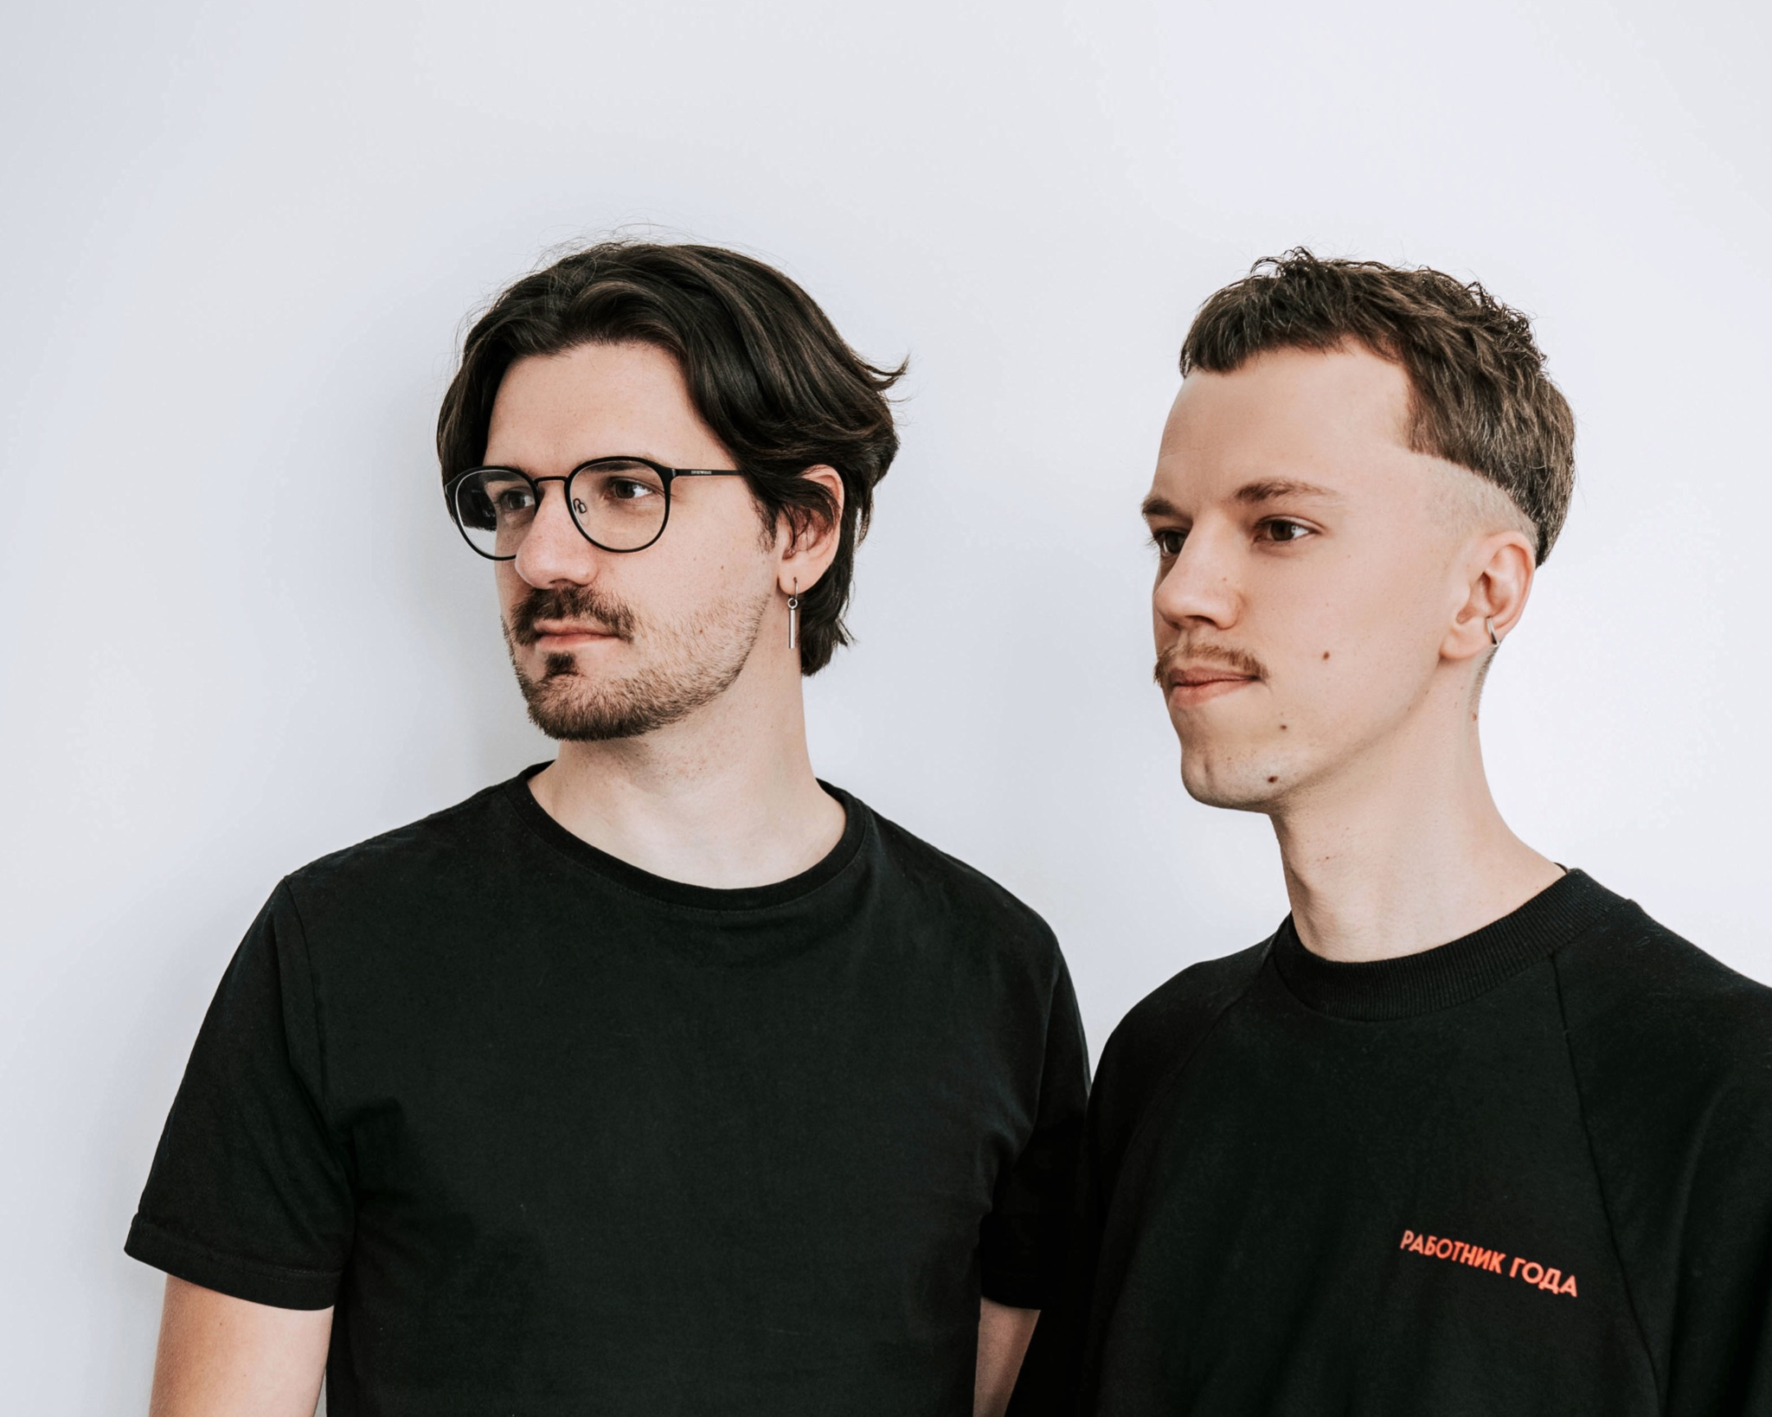

Team photos
Our team is located around the world therefore unfortunately we do not have yet made the full team common picture, yet here you may see photos of all team members here.
Download
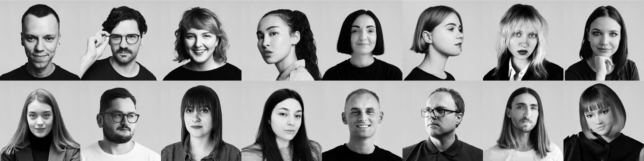

Contact us
Please feel free to contact Natalie for more information, she’d be delighted to help you out with whatever you have in mind.
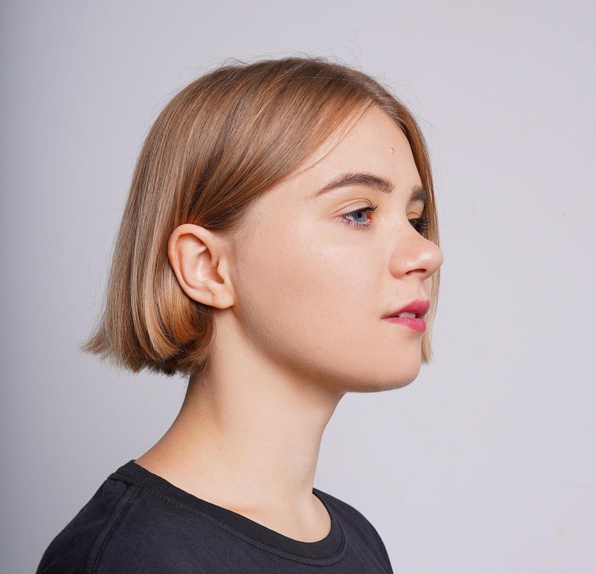

Natalie Novokhatnya
Head of PR
email: natalie@ffface.me
tel: +380 93 937 7777

